Revised Document: D900 – Exclusive Decorator Allocation within the IQ Conservator Space, Durham
National Program Launch: A Democratic and Legal Initiative
The NorthWest Finance Group, operating within the City of Durham, NC, has finalized updated pricing structures and retail closeout recommendations. A new callout rate has been established, and we invite you to engage with us directly regarding finance numbers and trade reaction protocols.
Please contact our office for detailed figures and operational guidance.
link: {office connect
link: {mayorial contacts

Potential Areas of Review
- Labor Relations — workforce coordination and compliance
- Democratic Standards — governance expectations
- Ethical Adjustments — policy alignment
- National Warranty — federal program assurances
- Shipwright Standards — technical and structural benchmarks
- Senatorial Connections — legislative engagement
- Professional Legal Services — advisory and representation
- Professional Tidying Standards — operational refinement
- Ethical Boundaries — compliance and oversight
- Korean National Trading Desk — international coordination
- Foreign Embassy Enterprise — diplomatic interfaces
- Technical Boundary Exploration — innovation and limits

Financial Scope
$800,000,000,000.00 allocated to IQ Conservator operations in Durham, NC and associated city centers.

Signature
(Signed in black ink)
Max Rupplin (MEARVK LLC)
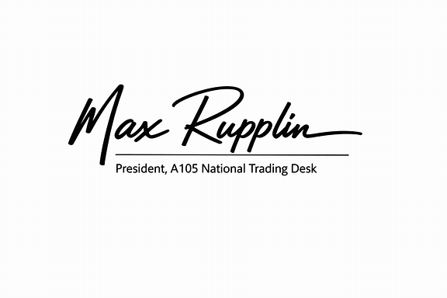
- President, A105 National Trading Desk
- Durham Democrat & Resident
- National ID: Financed
- Technical Liaison, City Finance
- 172-251 IQ Conservator

Language Availability
- Korean
- Japanese
- German
- French
- Spanish
- Vietnamese
- Thai
- Ukrainian
- Russian
- Chinese
- Hebrew
- English

